# Project Name: Implement Spring Security with Authentication.

## Output:

### Landing Page:



### Login Page:

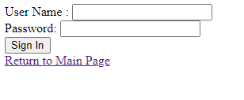

### Entering Credentials:

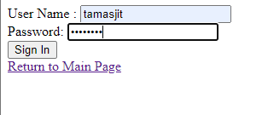

### Correct Credential Successful message:



### Wrong Credential input:

